

**LOVELY PROFESSIONAL UNIVERSITY**

**Hacker Blog**

**INTERNET PROGRAMMING LANGUAGE**

**(CSS, HTML5, JAVA SCRIPT)**

**CSE326**

**SUBMITTED BY:**

**MOHSIN MANZOOR BHAT (K19AZ.70)**

**Background And Objectives Of The Project**

The project assigned to me is about “Hacker Blog”. I have named my blog as “Neutrion Hackers”. The objective of the website is to make people aware about today’s technological world. This also gives users knowledge about the cyber world. This also tells the user, about various topics to learn about cyber world and hacking. After going through the blog one can understand the basics about security and cyber world and will get an idea to protect him/her self from the threats.

I have added various features to this blog .I have added buttons for navigation from one page to another page.

I have used HTML, CSS, JavaScript, and JQuery to design my blog.

The Website’s main page contains various articles to help users learn about technology. It contains various links of YouTube Channels, Websites and Blogs from where one can start to learn ethical hacking. It contains some links for daily news and articles about the Technological world and related things. It also gives the users an option to upload notes so they can contribute towards helping others.

It contains a page for Register/Sign In where one can register or login.

It contains a contact page where the user can fill the details and submit them to the admin to reach him. It also contains the social media account links of the admin, Photograph of the admin and address of the admin (Using Google Maps).

It contains a page about Cyber Crimes where information about cyber crimes is written in interactive way. I have used animation and Java Script to make the page look better. Some data is given in the form of timeline so that user will not get bored on seeing it.

It also contains a page about some basic topics in the internet world. Information is given in the form of cards with the background image related to each topic.

**Project Description**

The project is about creating a website on “Topics Related To Hacking”. I have named my website as “Neutrion Hackers”. The web page has 5 buttons clicking on which will direct us to new page. The following are the names of the buttons:

Let us discuss all the pages in detail one by one :

**1. Home page: -** I have designed the home page in such a way that it attracts the user when they open the website. I have linked my home page with 2 CSS files. The background of the page is a JPG image. At the top left corner I have placed the name of my website “Neutrion Hackers”. At the top right corner are placed buttons for navigation to remaining part of the website. Whenever the users click on any button they will be redirected to another page of the website in a new window. To place the buttons in position I have used “<div style="display:flex">” div tag. To make buttons look better and attractive I have linked then with CSS so they can be easily customized. Below buttons I have made a table in which I have placed some images and text in an innovative way so that users can read about the given topics in more convenient way. After that I have placed some key topics about hacking. I have used “<section id="section-a">” tags and linked it with CSS file to adjust alignment, background, text colour, fonts etc. I have enlightened on some key concepts about Hacking.

The topics are:-What is Hacking? , The objectives of hacking, Types of Hackers, Types of Hacking, How to guard against hacking? .I have also mentioned some topics in points, so that user can understand it very well.

After this I made a table which contains a list of websites, YouTube channels and blogs from where one can learn ethical hacking and some key concepts about cyber world. The table is divided into 3 sections one is for the Source Type next for Links and the last for Mode of learning. In the links section I have used buttons for the convenience of users. For these buttons I have used hover property to make them look more decent and attractive. When user puts cursor on the buttons they give shining effect and a hover effect. All the links are working well. When user clicks on any link it opens in a new tab.

After that I have made a section for uploading Notes. One can upload any type of file here. Upon clicking on submission the use will get this message from website “File Uploaded Successfully, thank You For Your Contribution”.

After that there is a section which gives us latest news and articles about the computer world and related things. Again I have used buttons with hover effect to make it look better.

At the last I have placed the developer’s name with the help of a gif image.

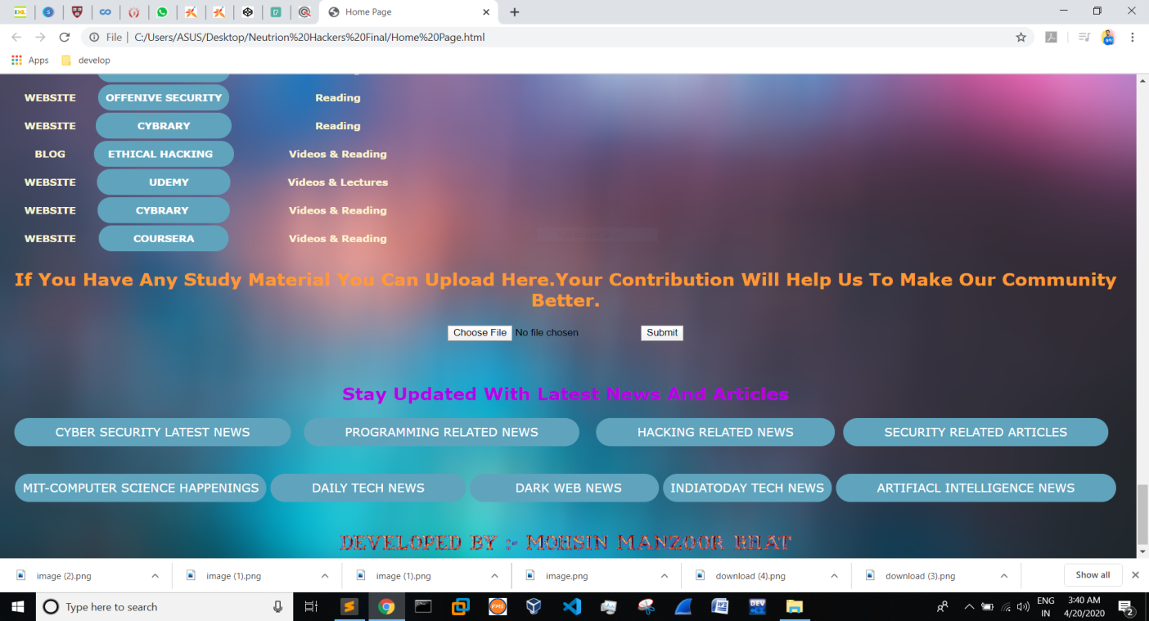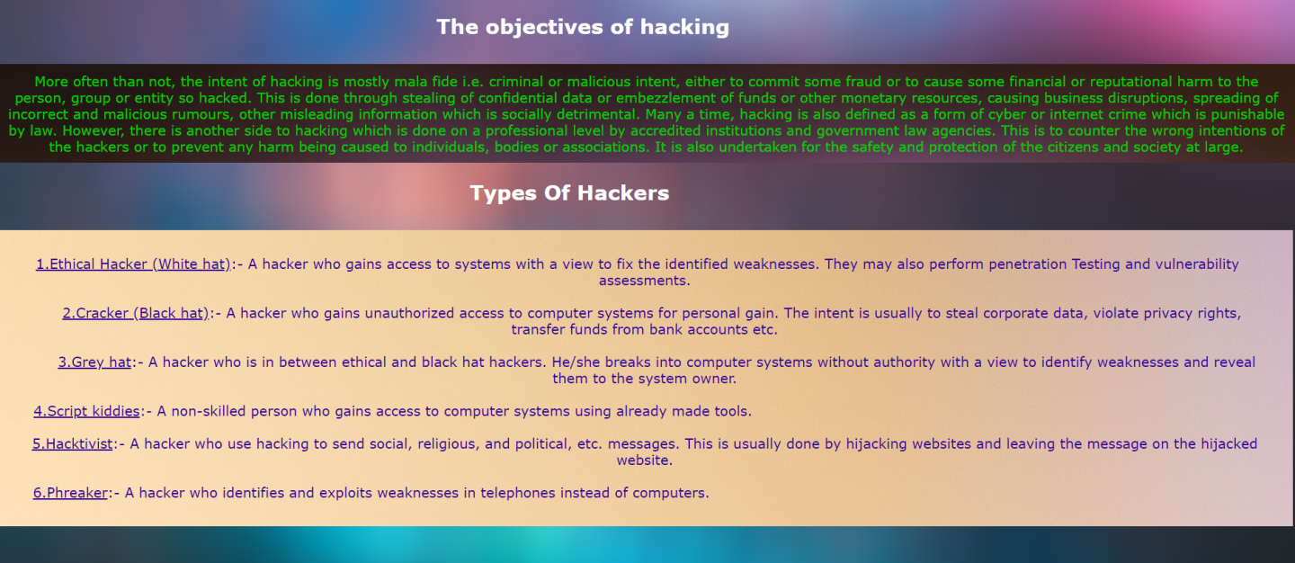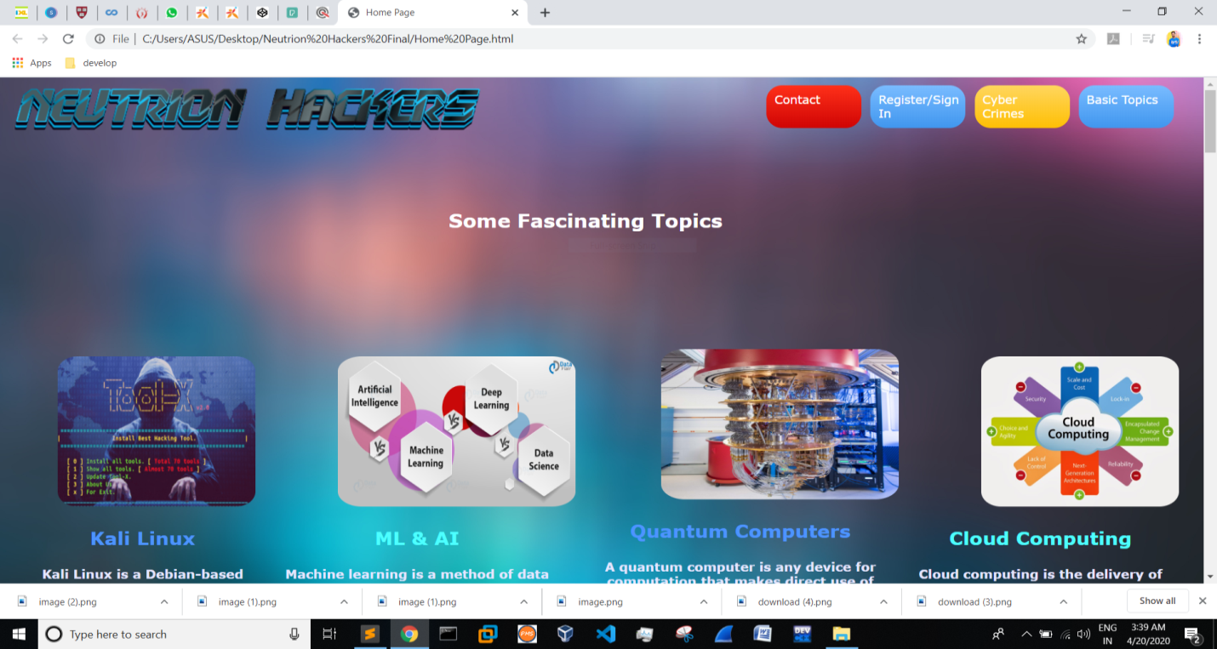 **Home Page**

2. **Contact Us**:- Starting from the top , at the top left corner is the name of the site and on the top right side are the navigation buttons from where a user can navigate to any page of the website.

A form is placed in this page where user can fill the details to give suggestions/feedbacks/complaints to the admin. The user has to give the following information: - Full Name, Email ID, Country and Subject (In which he can write anything he wants). There is a submit button upon clicking on it shows “Successfully Filled Details”. On the left side of the form is the photograph of the admin. On the extreme left are the sticky social media buttons which contains the social media accounts of the admin. Upon clicking on these buttons social media accounts of the admin will be shown in new tab from where one can easily contact the admin. Below the form is the address of the admin which is also marked in Google maps.

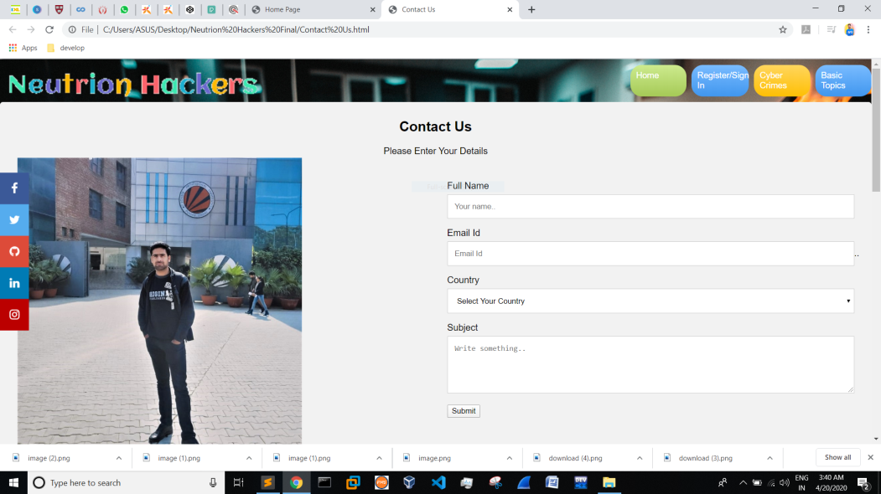

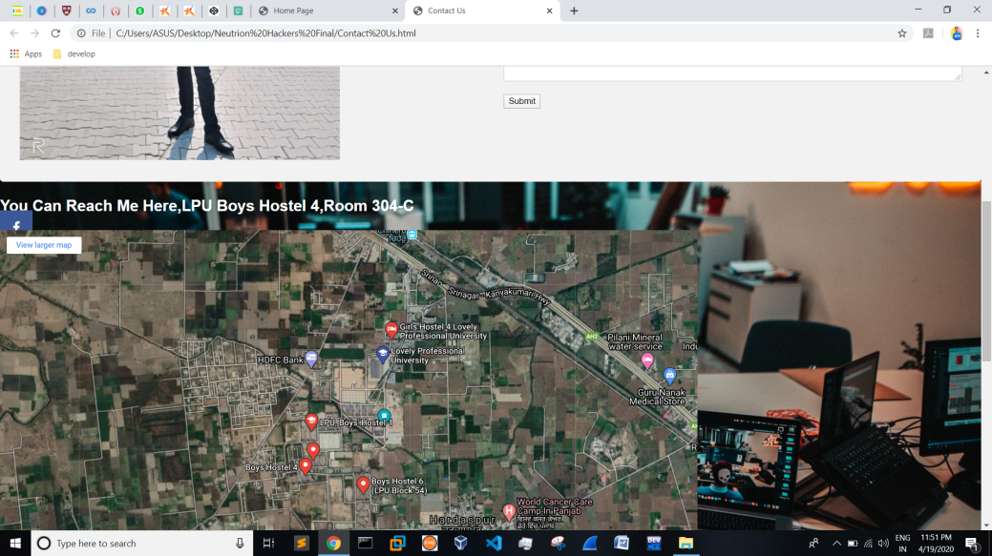

**Contact Page**

3. **Register/Sign In Page:-**

As in other pages this page also contains the name of the site at the top left corner and on the top right corner are the navigation buttons from where a user can navigate to any other page of the website. I have placed both login and register sections in one page for the convenience of the users.

User has to give Email Id and Password to login on the website .When the user clicks on the login button it shows the following message “Login Successful”. The login button also acts as a reset button .On the right side of the login Button is the Forget Password button on clicking that it shows “Mail Us on bhatmohsin1913@gmail.com From Your Registered Email Address”. It also acts as a reset button. I have used reset button and alert button simultaneously because it will look more real. If the user wants to login with Google account he can click on “Login With Google” and he will be redirect to the Gmail website in a new tab.

Below the login section is the Sign Up section. For sign up the user has to give the following information: - Full Name, Contact Number, Email Id, Password, Gender and D.O.B. It also contains a checkbox where user has to agree with the policies of the website. Upon clicking on Sign Up buttons it shows “You Have Successfully Registered”

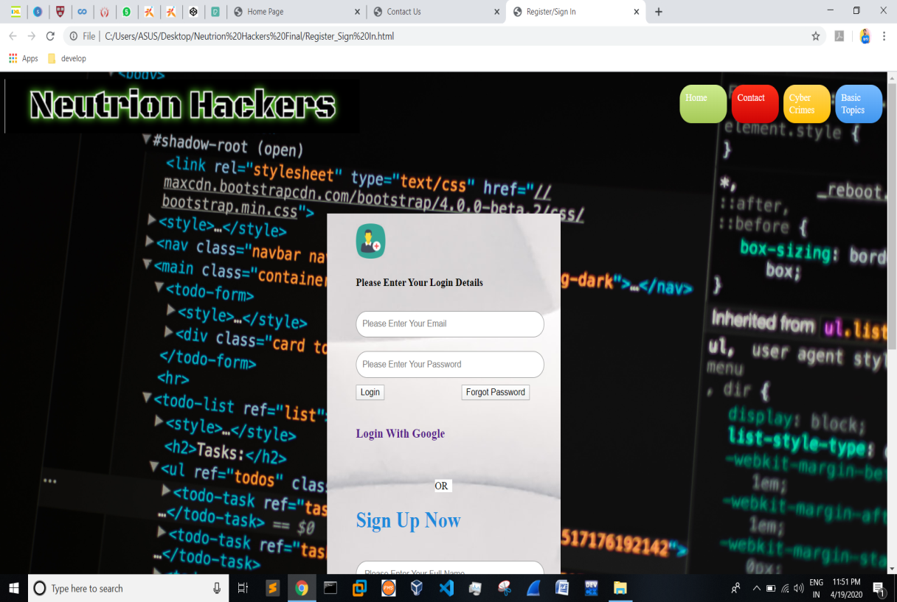

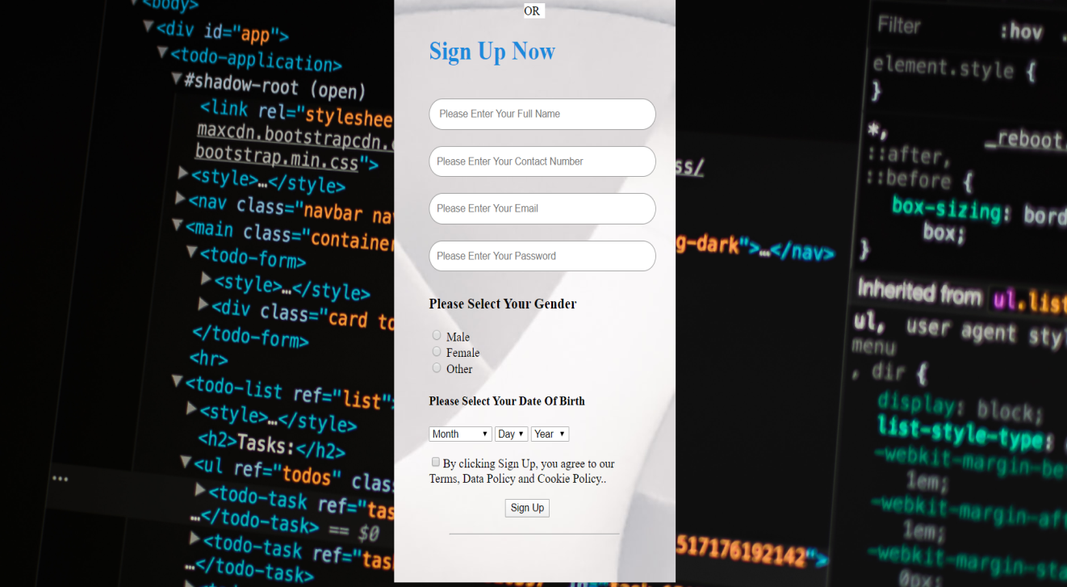 **Register/SignIn Page**

4 .**Cyber Crimes:**-I have dedicated a page to Cyber Crimes in my website because this topic is very interesting and trending. Directly or indirectly all of us are related to this topic. At the top left corner I have placed a transparent png image which contains the name of the website and at the top right corner are the navigation buttons.

Cyber Crimes written in black is animated. The table in which is written about cyber crime is made with the help of Java Script. The fonts are imported from various websites. Below it ,are written some articles and paragraphs related to cyber crimes. The topics are: - Why Cyber Crime Is A Threat ? , Cyber Crimes And Dark Web, Cyberbullying, Sexting, Identity theft. After that are written some big cyber Crimes of all time.

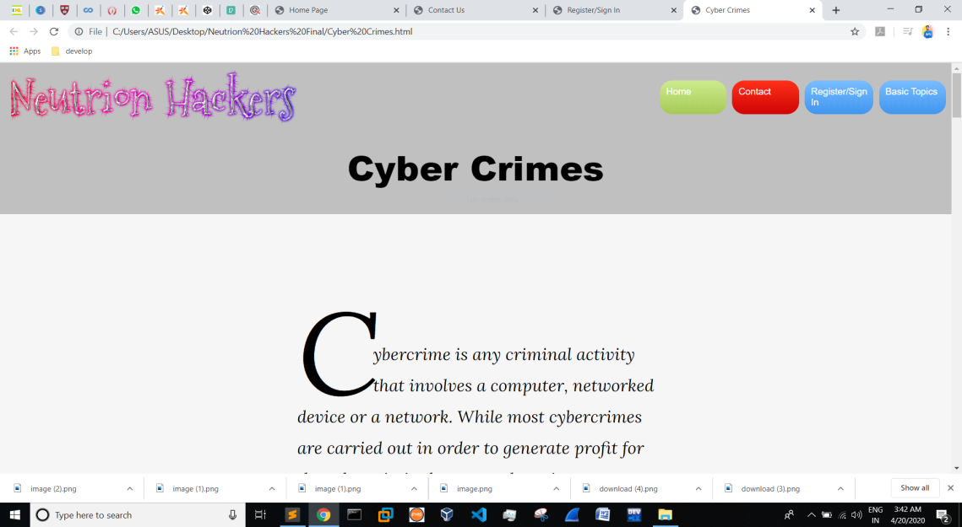

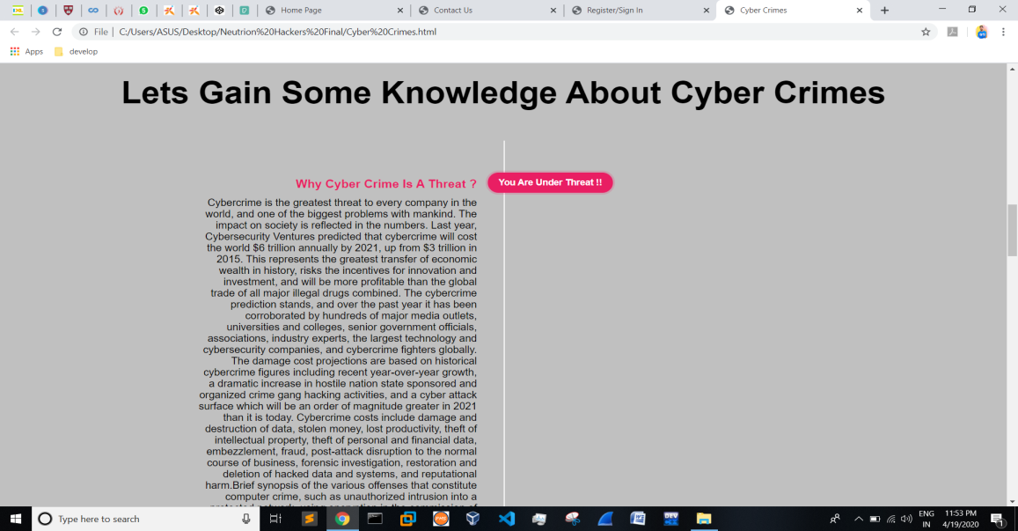

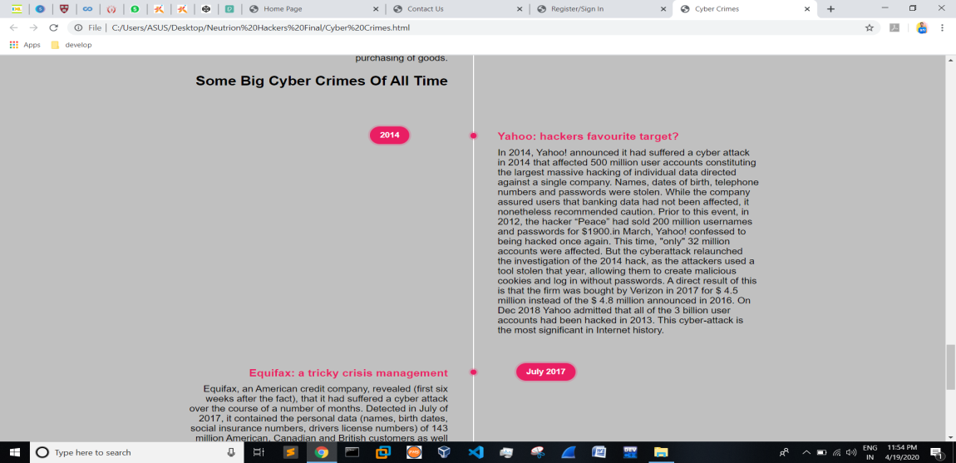

**Cyber Crimes Page**

5. **Basic Topics**: - This page contains some very basic topics to learn about the internet world. At the top left corner I have placed a transparent png image which contains the name of the website and at the top right corner are the navigation buttons.

I have made this page in form of cards. I have used “<div class="cardSlider">” tag .When user click on any topic it shows the information related to that topic only with the background image related to that very topic. The cards work very smoothly.

The topics in this page are: - What is Tor? , Crypto Currency, What Is the Dark Web? , Computer Forensics, A Little Darknet Knowledge.

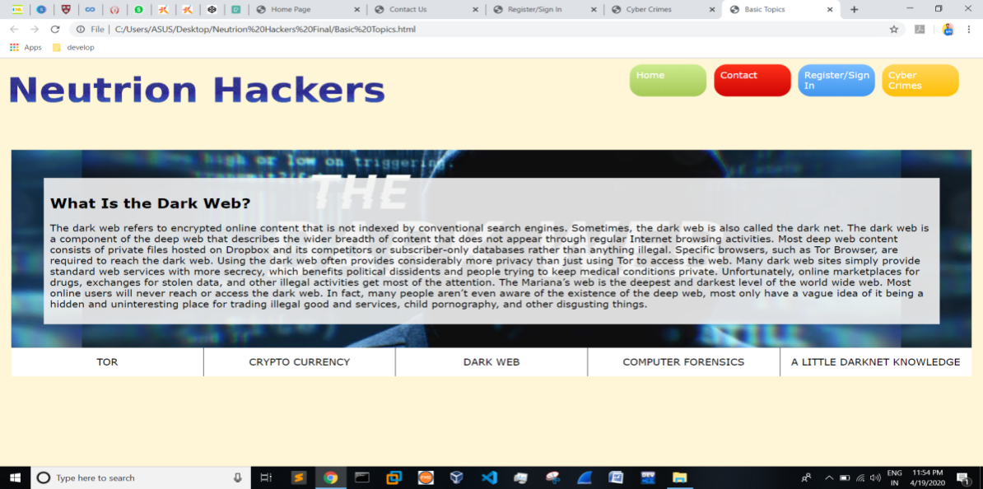

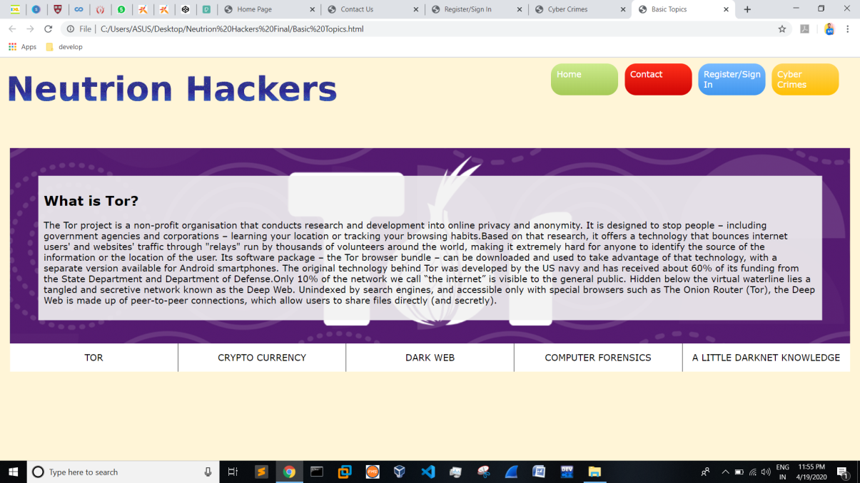

**Basic Topics Page**

**Technologies And Frameworks Used:-**

1. HTML, CSS, JavaScript and JQuery, Bootstrap

2. The most part of the project is made with Sublime Text and a little part with Atom.

**Websites Used:-**

1. <https://www.w3schools.com/>
2. <http://www.instantshift.com/>
3. <https://freshdesignweb.com/css3-social-media-buttons/>
4. <https://codepen.io/androidcss>
5. <https://engfto.com/>
6. <https://www.independent.co.uk/topic/dark-web?CMP=ILC-refresh>
7. <https://mdbootstrap.com/snippets/jquery/mdbootstrap/920555>
8. <https://github.com/filamentgroup/jQuery-Custom-File-Input/tree/master/js>
9. <https://colorlib.com/wp/bootstrap-file-uploads/>
10. <https://futuristspeaker.com/business-trends/the-future-of-the-darknet-9-critically-important-predictions/>
11. <https://www.elegantthemes.com/blog/resources/30-sans-serif-fonts-perfect-for-website-headings>
12. <https://www.colorhexa.com/web-safe-colors>
13. <https://www.ag.state.mn.us/Consumer/Publications/HowtoProtectYourselfAgainstHackers.asp>
14. <https://portswigger.net/web-security>
15. <https://www.cbinsights.com/research/report/quantum-computing/>
16. <https://www.cybrary.it/blog/0p3n/kali-linux-hackers-use-kali-linux-os/>
17. <https://www.whoishostingthis.com/blog/2017/03/07/tor-deep-web/>
18. <https://stackoverflow.com/questions/10707253/css-full-screen-div-with-text-in-the-middle>
19. <https://www.youtube.com/watch?v=hVdTQWASliE>
20. <https://www.kali.org/>
21. <https://www.fabriziovanmarciano.com/button-styles/?cn-reloaded=1>
22. <https://www.javatpoint.com/html-formatting>
23. <https://www.jqueryscript.net/animation/jQuery-Plugin-To-Create-Colorful-Wavy-Text-wavytext.html>
24. <https://freefrontend.com/css-headers-footers/>

Ways To Access My Website:-

1. [www.shorturl.at/bhyDG](http://www.shorturl.at/bhyDG)
2. <https://vpl5sig0zrvjleefbqkzwg-on.drv.tw/www.neutrionhackers.com/>
3. Link for my Google Drive where all files of the website are present

<https://drive.google.com/drive/folders/1M6xm2E688uplURjp1uD2tOgQOVEInGEC?usp=sharing>

1. <https://github.com/bhatmohsin1913/neutrionhackers>

Note: - While Trying Opening With link 1 and 2 you may get some error in text or animation because it is hosted on a free hosting side. For better results download the Google Drive folder in laptop and use it there hassle-free.

All images, screenshots, source codes are shared in the Google Drive Folder in an ordered manner.